Table of Contents

Web Scraping 1

Installing Selenium 1

Installing WebDriver for Chrome 2

Selector Gadget 3

Selenium 4

BeautifulSoup 4

Sleep 5

Parsing Out Data from Scraped Content 8

Removing Line Returns, Unwanted Tabs and Spaces 9

Sending Keys and Clicking Buttons 12

When Search Buttons Can’t Be Clicked 14

Selecting Paginated Links 16

Audio 19

Speech Recognition (Google API) 19

The SpeechRecognition Package 19

Installing Speech Recognition 20

Audio Files to Text 20

Duration 20

Offset 21

Using the Microphone 21

Installing the Microphone 21

## Web Scraping

This section offers a foundation in web scraping. Web scraping is the process of extracting content from web sites.

Web scraping requires a creative approached to text parsing. Even experienced coders can struggle with the countless ways needed to extract real content from mountains of text. The good news is you can almost always obtain the content that you want from the web with a bit of effort. This document shows how.

### Installing Selenium

There are several ways to conduct web scraping with Python. I have chosen selenium for this course because it offers robust, flexible and simple structures for scraping. Selenium is also a well-established and well-recognized framework in the developer community. Documentation for Selenium is located at:

<https://selenium-python.readthedocs.io/locating-elements.html>

To install Selenium and webdriver-manager run the following two commands in the IPython console of Spyder. You can also run these commands in the terminal window within PyCharm.

|  |
| --- |
| pip install selenium  pip install webdriver-manager |

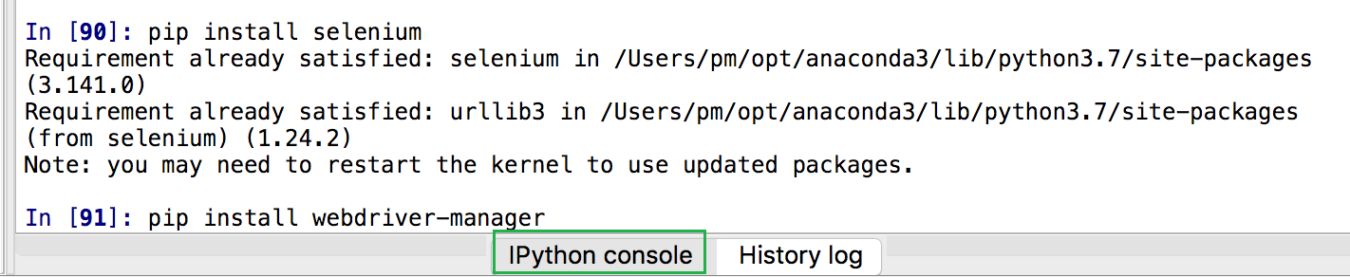

### Installing WebDriver for Chrome

While it is possible to use WebDriver with other browsers, I have had difficulty using anything else other than Chrome. I recommend using Chrome for now. To obtain WebDriver for Chrome, download an appropriate stable build from from <https://chromedriver.chromium.org/downloads>

**Note:**

It is important that the version number of your Chrome browser which is listed under **Help | About** generally matches the version of WebDriver that is used. My Chrome browser version is 108.0.5359.124:

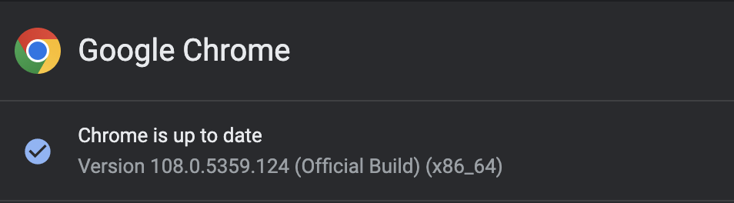

Because my browser is version 108.0.5359.124 I would download 108.0.5359.71 which should be a close enough match. It actually was compatible but if I needed a closer match I could always check the ChromeDriver archives for a closer match:



Extract the driver and place it in a folder that you can find easily.

Example 1: Testing Your Install

To test your selenium and web driver install, update and set the path according to whether you use Windows or Mac.

|  |
| --- |
| from selenium import webdriver  from selenium.webdriver.chrome.service import Service  PATH = "C:\\Foldername\\chromedriver.exe" # Windows  PATH = "/Users/pm/Documents/ChromeDriver/chromedriver" # Mac  # This loads webdriver from the local machine if it exists.  try:  driver = webdriver.Chrome(service=Service(PATH))  print("Success! The path to webdriver_manager was found.")  # If a webdriver not found error occurs it is then downloaded.  except:  print("webdriver not found. Update 'PATH' with file path in the download.") |

When you run Example 1, check the console output. If successful you will see the following output:

"Success! The path to webdriver_manager was found."

If you do not see the success message, try to determine if the path is correct and try again.

Exercise 1 (1 mark)

Place the path to your chromedriver here so you can refer to it later if needed.

|  |
| --- |
|  |

### Selector Gadget

Selector Gadget is a Chrome plugin that allows us to easily obtain unique CSS selectors and XPath queries to extract targeted sections of a web site. You can obtain Selector Gadget from:

<https://chrome.google.com/webstore/detail/selectorgadget/>

Example 2: Using Selector Gadget

Let’s scrape some movie reviews. First, we can use Selector Gadget to help find a CSS selector to identify the desired movie text. In Chrome navigate to:

<https://www.rottentomatoes.com/browse/movies_in_theaters/sort:newest?page=1>

Open Selector Gadget but selecting the plugin at the top right of your Chrome tab. Then place your cursor on some movie review text. The green and yellow colours identify all of the content that is selected. Currently though we really just want the movie review text for this example. Click on the text in the *Movie* and *Critic* columns to deselect the undesired text. The undesired text should then be highlighted in red to indicate that it will not be selected.

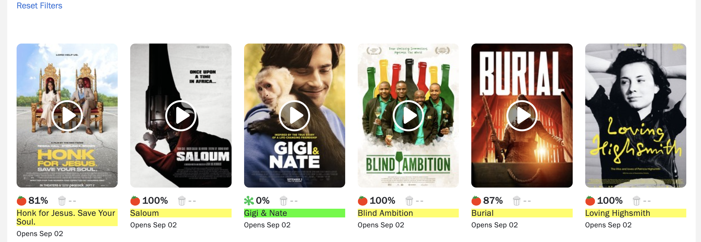

Now that we only have the ‘Review’ text highlighted we can obtain the CSS selector. You can copy the selector from the box provided by Selector Gadget at the bottom left of the browser window. I have also pasted the selector here:

|  |
| --- |
| **.p--small** |

### Selenium

We are going to start scraping soon. Selenium provides the following methods to locate a single element in a page. The two methods that we are going to use to locate the content identified by Selector Gadget are highlighted in green. Of course, you are welcome to experiment with the other methods as well.

find_element_by_id

find_element_by_name

find_element_by_xpath

find_element_by_link_text

find_element_by_partial_link_text

find_element_by_tag_name

find_element_by_class_name

find_element_by_css_selector

To find multiple elements (these methods will return a list):

find_elements_by_name

find_elements_by_xpath

find_elements_by_link_text

find_elements_by_partial_link_text

find_elements_by_tag_name

find_elements_by_class_name

find_elements_by_css_selector

For more information see:

<https://selenium-python.readthedocs.io/locating-elements.html>

### BeautifulSoup

To simplify the parsing of our scraped content we will use BeautifulSoup to remove the HTML tags. BeautifulSoup reduces our workload considerably.

soup = BeautifulSoup(start, features="lxml")

print(soup.get_text())

### Sleep

When we scrape with Selenium we are really extracting downloaded content that is delivered to our browser. To allow the browser enough time to load content before we scrape it we can use a *sleep()* function to pause the code.

# Sleep three seconds.

time.sleep(3)

Example 3: Scraping Rotten Tomatoes

Now that we have webdriver-manager from Example 1 and the CSS selector that we obtained in Example 2, we can scrape the data. This code extracts the actual reviews from RottenTomatoes.com:

|  |
| --- |
| DRIVER_PATH = "C:\\datasets\\chromedriver.exe"  DRIVER_PATH = "/Users/pm/Documents/ChromeDriver/chromedriver"  import time  from selenium import webdriver  from bs4 import BeautifulSoup  from selenium.webdriver.common.by import By  from selenium.webdriver.chrome.service import Service  browser = None  URL = "https://www.rottentomatoes.com/browse/movies_in_theaters/sort:newest?page=1"  browser = webdriver.Chrome(service=Service(DRIVER_PATH))  browser.get(URL)  # Give the browser time to load all content.  time.sleep(3)  content = browser.find_elements(By.CSS_SELECTOR, ".p--small")  for e in content:  start = e.get_attribute('innerHTML')  # Beautiful soup allows us to remove HTML tags from our content if it exists.  soup = BeautifulSoup(start, features="lxml")  print(soup.get_text())  print("***") # Go to new line. |

The output shows all reviews that are currently on the page that we scraped:

|  |
| --- |
| ﻿Puss in Boots: The Last Wish  ***  Roald Dahl's Matilda the Musical  ***  The Stranger  ***  1923  ***  Women Talking  … |

Exercise 2 (2 marks)

See if you can figure out how to scrape the opening date in addition to the movie title. Show your code here:

|  |
| --- |
|  |

Exercise 3 (3 marks)

See if you can scrape the course names for the Applied Data Analytics Certificate. The URL is:

URL = "https://www.bcit.ca/study/programs/5512cert#courses"

When you use Selector Gadget to obtain the content the values highlighted below will be selected.

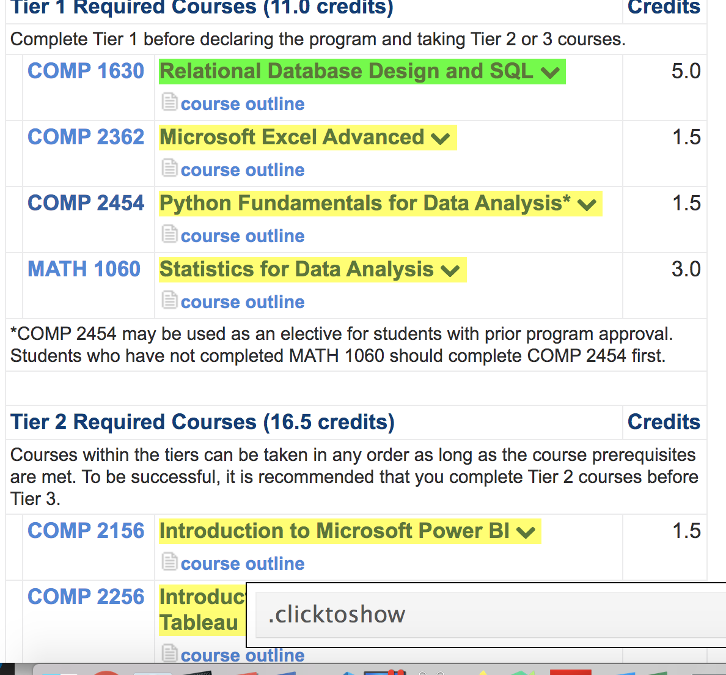

Show your code here:

|  |
| --- |
|  |

Show a screenshot of your output in the Python console window here:

|  |
| --- |
|  |

Example 4: Extracting Rows of Content

Until now we have scraped neighbouring reviews and ratings separately. Sometimes that works well. However, sometimes complex groupings of attributes must be scraped from a list. A reason for keeping all attributes for each item in a listing together is because some attributes for an item or event may be optional. Figure 1 shows a typical scenario with fields such as “Registration closed” or “Registration required” are optional. Trying to scrape these attributes separately may throw an error.

This example demonstrates how to extract each listing for the Vancouver Public Library as a separate block of content. To do this, in Chrome navigate to <https://vpl.bibliocommons.com/events/search/index>

Then, using Selector Gadget identify only the rows which contain the event name, date, time and location so your highlighting is similar to the following.

Figure 1: Vancouver Public Library Event Listings



The CSS selector for selecting an entire library event should appear as:

|  |
| --- |
| **.events-details-container** |

Now try running our scraping code from Example 3 with the updated hyperlink and CSS selector. The all information for each event in a list.

|  |
| --- |
| Jan5FeaturedSeniors' Morning at the Movies: Classic Films Based on BooksFeatured Event. Seniors' Morning at the Movies: Classic Films Based on Books10:00 AM – 12:30 PM10:00 AM to 12:30 PM | Thursday, January 05on January 5, 2023Central LibraryEvent location: Central LibraryCalling all seniors! Do you love to watch classic films based on classic books? Come to the Library’s Montalbano Theatre to enjoy a movie with your morning coffee, meet and mingle with other seniors, and chat about classic films and the…Book Clubs & Reading CirclesFind more events in: Book Clubs & Reading CirclesFilm ScreeningsFind more events in: Film ScreeningsMeetupsFind more events in: MeetupsSeniorsFind more events in: SeniorsEnglishFind more events in: English  ***  Jan3ESL Conversation Practice6:00 PM – 7:00 PM6:00 PM to 7:00 PM | Tuesday, January 03on January 3, 2023View all datesView all dates for: ESL Conversation PracticeCollingwood BranchEvent location: Collingwood BranchMeet new friends and practice your English conversation skills with other English language learners. This is a supportive and casual meet-up.  For intermediate speakers.Drop in.ESL Conversation PracticeFind more events in: ESL Conversation PracticeMeetupsFind more events in: MeetupsAdultsFind more events in: AdultsESL LearnersFind more events in: ESL LearnersNewcomersFind more events in: Newcomers  ***  Jan4Career and Job Search Tour10:30 AM – 12:00 PM10:30 AM to 12:00 PM | Wednesday, January 04on January 4, 2023View all datesView all dates for: Career and Job Search TourOnline eventAre you exploring careers or looking for a job? Want to know how to find unadvertised jobs and access the hidden job market? Register for this free workshop, which introduces you to VPL's extensive job and career resources. Everyone is…Join waitlist for Career and Job Search Tour on 01-04-2023Registration fullJoin waitlistSkilled Immigrant InfoCentreFind more events in: Skilled Immigrant InfoCentreBusiness & Employment WorkshopsFind more events in: Business & Employment WorkshopsClasses & WorkshopsFind more events in: Classes & WorkshopsAdultsFind more events in: AdultsNewcomersFind more events in: Newcomers  ***  Jan4ESL Conversation Practice Online11:00 AM – 12:00 PM11:00 AM to 12:00 PM | Wednesday, January 04on January 4, 2023View all datesView all dates for: ESL Conversation Practice OnlineOnline eventMeet new friends and practice your English conversation skills with other English language learners. This is a supportive and casual meet-up using Zoom.  For intermediate speakers.  To join this Zoom event you will need a computer, tablet or…Register for ESL Conversation Practice Online on 01-04-2023Registration required (6 spots remaining)Register for eventESL Conversation PracticeFind more events in: ESL Conversation PracticeMeetupsFind more events in: MeetupsAdultsFind more events in: AdultsNewcomersFind more events in: NewcomersEnglishFind more events in: English  ***  Jan5Family Storytime11:00 AM – 11:30 AM11:00 AM to 11:30 AM | Thursday, January 05on January 5, 2023View all datesView all dates for: Family StorytimeJoe Fortes BranchEvent location: Joe Fortes BranchA program for parents and caregivers with young children. Songs,  rhymes and stories are shared. Suitable for children of all ages and  abilities to enjoy and learn together.  StorytimesFind more events in: StorytimesPreschool Age ChildrenFind more events in: Preschool Age ChildrenToddlersFind more events in: ToddlersEnglishFind more events in: English  ***  Jan5SFU Writer’s Studio Writing Consults at Central Library1:00 PM – 4:00 PM1:00 PM to 4:00 PM | Thursday, January 05on January 5, 2023View all datesView all dates for: SFU Writer’s Studio Writing Consults at Central LibraryCentral LibraryEvent location: Central LibraryNeed an expert opinion on your writing, or a nudge in the right direction? The SFU Writer's Studio is offering free 45-minute one-on-one manuscript consultations. Submit up to seven (7) pages of your prose or poetry. You will receive…Registration closedClasses & WorkshopsFind more events in: Classes & WorkshopsAdultsFind more events in: AdultsEnglishFind more events in: English  ***… |

## Parsing Out Data from Scraped Content

Parsing out content takes some trial and error and since web content can be presented in infinite ways there is no perfect solution. While this is not a course in Python development, I will demonstrate some basic parsing methods that can handle a large percentage of situations.

### Removing Line Returns, Unwanted Tabs and Spaces

Sometimes unwanted characters will appear in the content. Carriage returns and tabs cannot be seen directly in the output but they can add unwanted empty spaces to the output. Characters such as \n or \t can be seen in the debugger so remember to check the debugger if you are uncertain about which character is distorting the output. These code snippets show how to remove unwanted characters:

# Remove hidden characters for tabs and new lines.

rawString = re.sub(r"[\n\t]", "", rawString)

# Replace two or more consecutive empty spaces with '*'.

rawString = re.sub('[ ]{2,}', '', rawString)

# Replace old string with new string.

rawString.replace("Old String", "New String*")

Example 5: Custom Parsing

The content from Example 4 is grouped by Vancouver Public Library event. This is a great start but now we need to isolate fields of data. Also, we want to remove the unnecessary data as well as unwanted and hidden characters in the scraped content from Example 4.

|  |
| --- |
| DRIVER_PATH = "C:\\datasets\\chromedriver.exe"  DRIVER_PATH = "/Users/pm/Documents/ChromeDriver/chromedriver"  from selenium.webdriver.chrome.service import Service  import re  import time  from selenium import webdriver  from bs4 import BeautifulSoup  from selenium.webdriver.common.by import By  browser = None  URL = "https://vpl.bibliocommons.com/events/search/index"  browser = webdriver.Chrome(service=Service(DRIVER_PATH))  browser.get(URL)  # Give the browser time to load all content.  time.sleep(3)  libraryEvents = browser.find_elements(By.CSS_SELECTOR,  ".events-details-container")  # Uses BeautifulSoup and Regex to remove HTML and  # unwanted characters.  def removeHtmlAndUnwantedCharacters(contents):  htmlRemoved = contents.get_attribute('innerHTML')  # Beautiful soup allows us to remove HTML tags from our content if it exists.  soup = BeautifulSoup(htmlRemoved, features="lxml")  textOnly = soup.get_text()  # Remove hidden carriage returns and tabs.  textOnly = re.sub(r"[\n\t]*", "", textOnly)  # Replace two or more consecutive empty spaces with '*'  textOnly = re.sub('[ ]{2,}', '*', textOnly)  return textOnly  def extractTime(startTimePosition, content):  endPosition = -1  firstHypenPosition = content.find(" – ")  for i in range(firstHypenPosition, len(content)):  substring = content[i:i + 2]  if (substring == "AM" or substring == "PM"):  endPosition = i + 2  break  timeString = content[startTimePosition:endPosition]  return timeString  def extractTitle(content):  # Title occurs right after 1st number and ends at 2nd number.  # Example: "Summer Reading Club Celebration" is found in  # "Aug31Summer Reading Club Celebration3:00 P"  startNumberFound = False  startPosition = -1  endTitlePosition = -1  for i in range(0, len(content)):  character = content[i]  try:  parsedNumber = int(character)  if (not startNumberFound):  startNumberFound = True  elif startPosition != -1:  endTitlePosition = i  break  except:  if (startNumberFound and startPosition == -1):  startPosition = i  title = content[startPosition:endTitlePosition]  return title, endTitlePosition  def getDate(content):  barPosition = content.find("|")  onPosition = -1  for i in range(barPosition, len(content)):  substring = content[i:i + 2]  if (substring == 'on'):  onPosition = i  break  dateString = content[barPosition + 2:onPosition]  return dateString  for libraryEvent in libraryEvents:  textContent = removeHtmlAndUnwantedCharacters(libraryEvent)  print(textContent)  title, endTitlePosition = extractTitle(textContent)  timeString = extractTime(endTitlePosition, textContent)  dateString = getDate(textContent)  print("Title: " + title)  print("Time: " + timeString)  print("Date: " + dateString)  print("***") # Go to new line. |

Notice how the content has now been separated into a manageable format. This is good for now but often scraping code needs adjustments if the web site changes format without any notice.

|  |
| --- |
| ***  Jan3ESL Conversation Practice6:00 PM – 7:00 PM6:00 PM to 7:00 PM | Tuesday, January 03on January 3, 2023View all datesView all dates for: ESL Conversation PracticeCollingwood BranchEvent location: Collingwood BranchMeet new friends and practice your English conversation skills with other English language learners. This is a supportive and casual meet-up. For intermediate speakers.Drop in.ESL Conversation PracticeFind more events in: ESL Conversation PracticeMeetupsFind more events in: MeetupsAdultsFind more events in: AdultsESL LearnersFind more events in: ESL LearnersNewcomersFind more events in: Newcomers  Title: ESL Conversation Practice  Time: 6:00 PM – 7:00 PM  Date: Tuesday, January 03  ***  Jan4Career and Job Search Tour10:30 AM – 12:00 PM10:30 AM to 12:00 PM | Wednesday, January 04on January 4, 2023View all datesView all dates for: Career and Job Search TourOnline eventAre you exploring careers or looking for a job? Want to know how to find unadvertised jobs and access the hidden job market? Register for this free workshop, which introduces you to VPL's extensive job and career resources. Everyone is…Join waitlist for Career and Job Search Tour on 01-04-2023Registration fullJoin waitlistSkilled Immigrant InfoCentreFind more events in: Skilled Immigrant InfoCentreBusiness & Employment WorkshopsFind more events in: Business & Employment WorkshopsClasses & WorkshopsFind more events in: Classes & WorkshopsAdultsFind more events in: AdultsNewcomersFind more events in: Newcomers  Title: Career and Job Search Tour  Time: 10:30 AM – 12:00 PM  Date: Wednesday, January 04  ***  Jan4ESL Conversation Practice Online11:00 AM – 12:00 PM11:00 AM to 12:00 PM | Wednesday, January 04on January 4, 2023View all datesView all dates for: ESL Conversation Practice OnlineOnline eventMeet new friends and practice your English conversation skills with other English language learners. This is a supportive and casual meet-up using Zoom.For intermediate speakers.To join this Zoom event you will need a computer, tablet or…Register for ESL Conversation Practice Online on 01-04-2023Registration required (6 spots remaining)Register for eventESL Conversation PracticeFind more events in: ESL Conversation PracticeMeetupsFind more events in: MeetupsAdultsFind more events in: AdultsNewcomersFind more events in: NewcomersEnglishFind more events in: English  Title: ESL Conversation Practice Online  Time: 11:00 AM – 12:00 PM  Date: Wednesday, January 04  ***  Jan5Family Storytime11:00 AM – 11:30 AM11:00 AM to 11:30 AM | Thursday, January 05on January 5, 2023View all datesView all dates for: Family StorytimeJoe Fortes BranchEvent location: Joe Fortes BranchA program for parents and caregivers with young children. Songs, rhymes and stories are shared. Suitable for children of all ages and abilities to enjoy and learn together.StorytimesFind more events in: StorytimesPreschool Age ChildrenFind more events in: Preschool Age ChildrenToddlersFind more events in: ToddlersEnglishFind more events in: English  Title: Family Storytime  Time: 11:00 AM – 11:30 AM  Date: Thursday, January 05  *** |

### Sending Keys and Clicking Buttons

It is possible to send keys to input boxes. To automate a search for a specific topic on the AnimalFactGuide website we could find the search textbox with the CSS selector and use Selenium’s *send_keys()* function to input the word “Zebras”.

# Find the search input.

search = browser.find_element_by_css_selector("#s")

search.send_keys("Zebra")

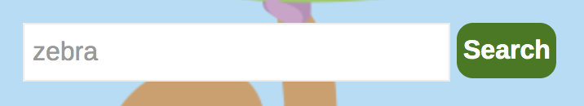

After sending keys we can then click the button to trigger the search:

# Find the search button - this is only enabled when a search query is entered

button = browser.find_element_by_css_selector("#searchsubmit")

button.click() # Click the button.

Clicking on the search button brings up the search results which we can then scrape.

Example 6: Submitting a Search Query

This example shows how to submit a query about zebras through a search box.

|  |
| --- |
| DRIVER_PATH = "C:\\datasets\\chromedriver.exe"  DRIVER_PATH = "/Users/pm/Documents/ChromeDriver/chromedriver"  from selenium.webdriver.chrome.service import Service  import time  from selenium import webdriver  from bs4 import BeautifulSoup  from selenium.webdriver.common.by import By  URL = "https://animalfactguide.com/links/"  browser = webdriver.Chrome(service=Service(DRIVER_PATH))  browser.get(URL)  # Give the browser time to load all content.  time.sleep(3)  libraryEvents = browser.find_elements(By.CSS_SELECTOR,  ".events-details-container")  # Find the search input.  search = browser.find_element(By.CSS_SELECTOR,"#s")  search.send_keys("Zebra")  # Find the search button - this is only enabled when a search query is entered  button = browser.find_element(By.CSS_SELECTOR, "#searchsubmit")  button.click() # Click the button.  time.sleep(3)  # Extracts text from scraped content.  def extractText(data):  text = data.get_attribute('innerHTML')  soup = BeautifulSoup(text, features="lxml")  content = soup.get_text()  return content  titles = browser.find_elements(By.CSS_SELECTOR,".entry-title a")  descriptions = browser.find_elements(By.CSS_SELECTOR, ".entry-summary p")  titleList = []  descriptionList = []  for i in range(0, len(titles)):  # extract title and add to list.  title = extractText(titles[i])  titleList.append(title)  # extract description and add to list.  description = extractText(descriptions[i])  descriptionList.append(description)  # Show the content.  for i in range(0, len(descriptionList)):  print("\n********************")  print("Title: " + titleList[i])  print("Description: " + descriptionList[i]) |

## When Search Buttons Can’t Be Clicked

Sometimes text boxes such as search boxes exist for text entry yet the submit button cannot be clicked with Selenium. In these situations the send_keys() function can be used to send a RETURN key to text box to trigger the search:

search.send_keys(Keys.RETURN)

Example 7: Using send_keys(Keys.RETURN)

This code demonstrates a way to submit text by sending Keys.RETURN to the text box. For this case, “Analytics” is sent to the text box and it is submitted with the Keys.RETURN entry.

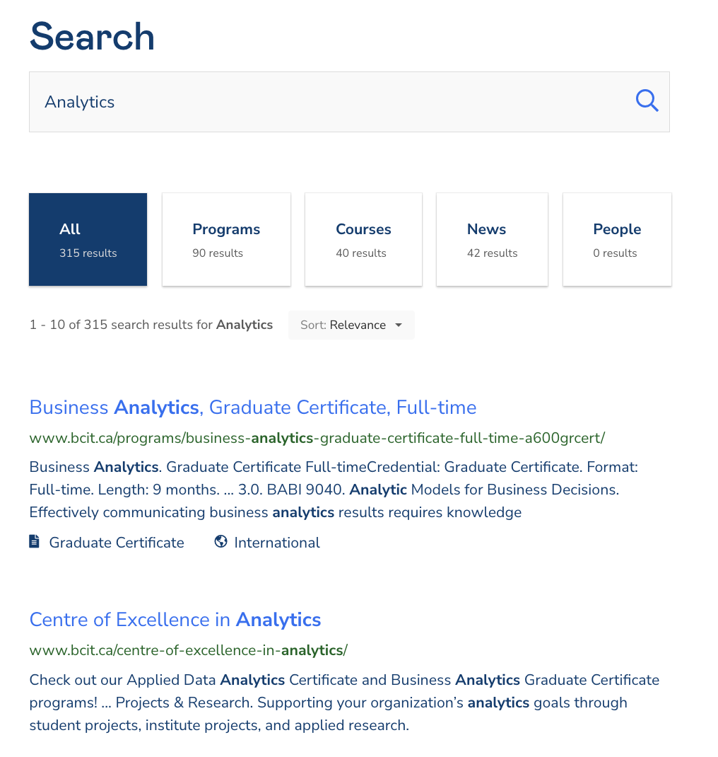

|  |
| --- |
| DRIVER_PATH = "C:\\datasets\\chromedriver.exe"  DRIVER_PATH = "/Users/pm/Documents/ChromeDriver/chromedriver"  from selenium.webdriver.chrome.service import Service  from selenium.webdriver.common.keys import Keys  import time  from selenium import webdriver  from selenium.webdriver.common.by import By  browser = None  URL = "https://www.bcit.ca/"  browser = webdriver.Chrome(service=Service(DRIVER_PATH))  browser.get(URL)  # Give the browser time to load all content.  time.sleep(3)  # Find the search input.  search = browser.find_element(By.CSS_SELECTOR,"#site-header-search")  search.send_keys("Analytics")  # Even when there is a search button sometimes it is not clickable.  # However, sometimes you can send a return key and this will initiate  # the search.  search.send_keys(Keys.RETURN) |

Example 8: Scraping Search Items

This example continues from Example 7 to scrape the content that is retrieved from the search on the topic of “Analytics”.

|  |
| --- |
| # Give the browser time to load all content.  time.sleep(3)  searchItems =\  browser.find_elements(By.CSS_SELECTOR, ".bcit-search-results__title")  # Uses BeautifulSoup and Regex to remove HTML and  # unwanted characters.  def removeHtmlAndUnwantedCharacters(contents):  htmlRemoved = contents.get_attribute('innerHTML')  # Beautiful soup allows us to remove HTML tags from our content if it exists.  soup = BeautifulSoup(htmlRemoved, features="lxml")  textOnly = soup.get_text()  # Remove hidden carriage returns and tabs.  textOnly = re.sub(r"[\n\t]*", "", textOnly)  # Replace two or more consecutive single space.  textOnly = re.sub('[ ]{2,}', ' ', textOnly)  return textOnly.strip() # remove leading and trailing spaces.  for searchItem in searchItems:  textContent = removeHtmlAndUnwantedCharacters(searchItem)  print(textContent) |

The output shows the titles of items that are retrieved during the search:

|  |
| --- |
| Business Analytics, Graduate Certificate, Full-time  Centre of Excellence in Analytics  Analytics meetup brings industry experts to BCIT – BCIT News  Data Analytics Fundamentals (COMP 2854)  Courses  Areas of Study  Institutional Research and Planning  Web Analytics  2017 Results  Classroom Locations |

### Selecting Paginated Links

Often when automating searches, you are presented with paginated links like the following:

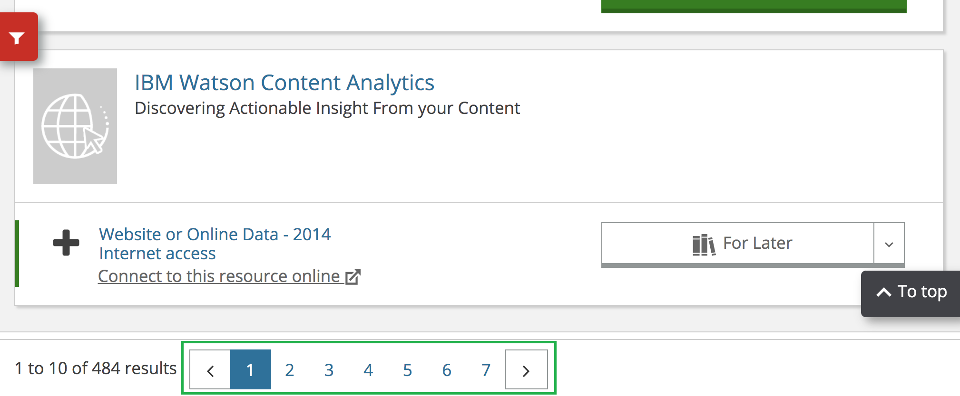

You cannot use the click() function to select these links so instead create the URL with the page number parameter and incrementally advance through the pages.

|  |
| --- |
| # Go to a new page.  pageNum += 1  URL_NEXT = "https://burnaby.bibliocommons.com/v2/search?query=" \  + SEARCH_TERM + "&searchType=smart&pagination_page="  URL_NEXT = URL_NEXT + str(pageNum)  browser.get(URL_NEXT)  print("Count: ", str(i))  time.sleep(3) |

Example 9: Automating Searches with Search Boxes and Pagination

This example shows how to automate a search on analytics content at the Burnaby Public Library site. The example iterates through six pages of the site by navigating to the different paginated links.

Also note how more than one item is scraped from each page. Using multiple selectors helps to simplify the code by reducing the parsing needed in the application.

|  |
| --- |
| DRIVER_PATH = "C:\\datasets\\chromedriver.exe"  DRIVER_PATH = "/Users/pm/Documents/ChromeDriver/chromedriver"  from selenium.webdriver.chrome.service import Service  import re  import time  from selenium import webdriver  from bs4 import BeautifulSoup  from selenium.webdriver.common.by import By  browser = None  URL = "https://bpl.bc.ca/events/"  browser = webdriver.Chrome(service=Service(DRIVER_PATH))  browser.get(URL)  # Give the browser time to load all content.  time.sleep(1)  SEARCH_TERM = "Analytics"  search = browser.find_element(By.CSS_SELECTOR, "input")  search.send_keys(SEARCH_TERM)  # Find the search button - this is only enabled when a search query is entered  button = browser.find_element(By.CSS_SELECTOR, "button")  button.click() # Click the button.  time.sleep(3)  def getContent(content):  textContent =content.get_attribute('innerHTML')  # Beautiful soup removes HTML tags from our content if it exists.  soup = BeautifulSoup(textContent, features="lxml")  rawString = soup.get_text().strip()  # Remove hidden characters for tabs and new lines.  rawString = re.sub(r"[\n\t]*", "", rawString)  # Replace two or more consecutive empty spaces with '*'  rawString = re.sub('[ ]{2,}', '*', rawString)  return rawString  # content = browser.find_elements_by_css_selector(".cp-search-result-item-content")  pageNum = 1;  for i in range(0, 5):  titles = browser.find_elements(By.CSS_SELECTOR, ".title-content")  formats = browser.find_elements(By.CSS_SELECTOR, ".manifestation-item-format-info-wrap")  NUM_ITEMS = len(titles)  # This technique works only if counts of all scraped items match.  if(len(titles)!=NUM_ITEMS or len(formats)!=NUM_ITEMS):  print("**WARNING: Items scraped are misaligned because their counts differ")  for i in range(0, NUM_ITEMS):  title = getContent(titles[i])  mediaFormat = getContent(formats[i])  print("Title: " + title)  print("Media: " + mediaFormat)  print("********")  # Go to a new page.  pageNum += 1  URL_NEXT = "https://burnaby.bibliocommons.com/v2/search?query=" \  + SEARCH_TERM + "&searchType=smart&pagination_page="  URL_NEXT = URL_NEXT + str(pageNum)  browser.get(URL_NEXT)  print("Count: ", str(i))  time.sleep(3)  browser.quit()  print("done loop") |

Exercise 4 (1 mark)

Why is the sleep function used in Example 9?

|  |
| --- |
|  |

Exercise 5 (3 marks)

Modify Example 9 so it scrapes 10 pages. Also use a third selector to extract and show information about whether the resource is available or if it can be accessed online. The items needed are highlighted below:

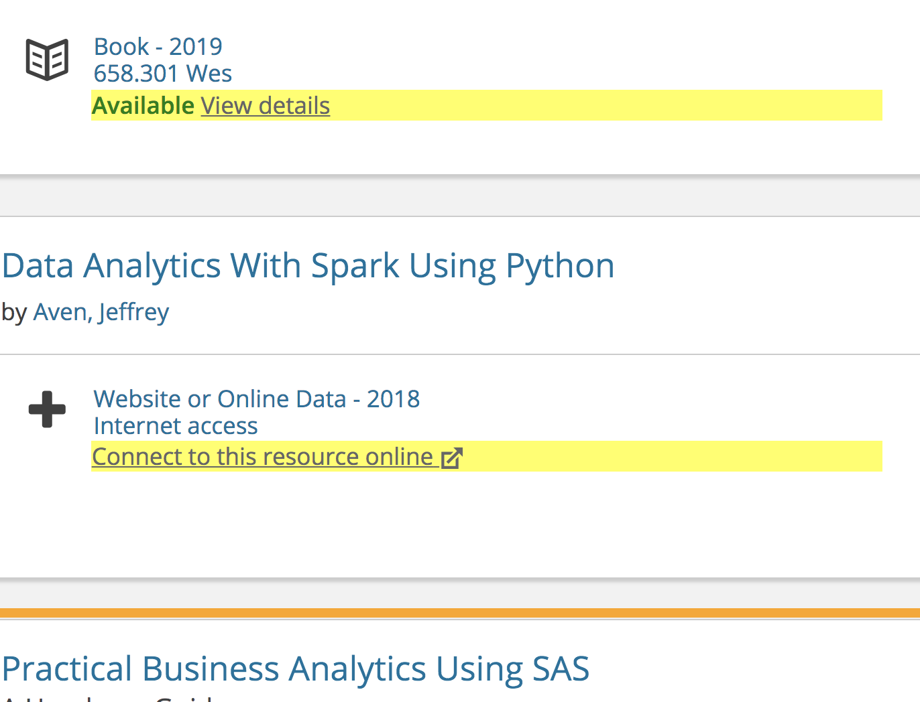

Show your revised program here:

|  |
| --- |
|  |

Show a screenshot of a few sample rows of output here:

|  |
| --- |
|  |

Exercise 6 (10 marks)

Figure out how to perform an automated search on a site that interested you (which is not included in this document) which displays paginated results. Display the content of at least three pages of the search results. Show your full program here:

|  |
| --- |
|  |

Show a screenshot of some output from your search here:

|  |
| --- |
|  |

# Audio

## Speech Recognition (Google API)

Please see <https://realpython.com/python-speech-recognition/> for more detail on the discussion in this section. In your search for data, you may need to extract large amounts of text from audio. There are several Python API’s to do this which include:

* apiai
* assemblyai
* google-cloud-speech
* pocketsphinx
* SpeechRecognition
* watson-developer-cloud
* wit

### The SpeechRecognition Package

We will use the SpeechRecognition package as an alternative for extracting text from audio. The SpeechRecognition library acts as a wrapper for several popular speech APIs and is thus extremely flexible. One of these—the Google Web Speech API—supports a default API key that is hard-coded into the SpeechRecognition library. That means you can get started without having to sign up for a service.

#### The Recognizer Class

The Recognizer class is used to extract text from audio. Each Recognizer instance has seven methods for recognizing speech from an audio source using various APIs. These are:

* recognize_bing(): Microsoft Bing Speech
* recognize_google(): Google Web Speech API
* recognize_google_cloud(): Google Cloud Speech - requires installation of the google-cloud-speech package
* recognize_houndify(): Houndify by SoundHound
* recognize_ibm(): IBM Speech to Text
* recognize_sphinx(): CMU Sphinx - requires installing PocketSphinx
* recognize_wit(): Wit.ai

### Installing Speech Recognition

Example 10: Installing Speech Recognition

To begin, you must install SpeechRecognition using pip.

pip install SpeechRecognition

Once SpeechRecognition is installed, we can use it to extract the text from various audio sources.

### Audio Files to Text

Example 11: Speech-to-Text

This example shows how to extract text from a wave file. The audio file samples are available in the **audiosamples1.zip** archive which can be found in the data sets area in the Learning Hub. Depending on your internet connection speed, you may have to wait several seconds before seeing the result. The example however does correctly print Elaine’s sentence:

“he is lazy”

|  |
| --- |
| import speech_recognition as sr  PATH = "/Users/pm/Desktop/DayDocs/data/audiosamples1/elaine_0.wav"  r = sr.Recognizer()  audioFile = sr.AudioFile(PATH)  with audioFile as source:  audio = r.record(source)  output = r.recognize_google(audio)  print(output) |

### Duration

You may want to extract audio into different segments. To do this, you can use the duration attribute to set the time duration for each section. The speech recognizer will automatically advance to the next section after each recording.

Example 12: Breaking the audio clip into sections with duration

This code uses the duration attribute to break Kramer’s sentences into two separate sections:

“and I really love her”

“I'm going to ask her to marry me”

|  |
| --- |
| import speech_recognition as sr  PATH = "/Users/pm/Desktop/DayDocs/data/audiosamples1/kramer_3.wav"  r = sr.Recognizer()  jackhammer = sr.AudioFile(PATH)  with jackhammer as source:  audio1 = r.record(source, duration=1.5)  audio2 = r.record(source, duration=1.2)  # Shows first section.  output1 = r.recognize_google(audio1)  print(output1)  # Shows second section.  output2 = r.recognize_google(audio2)  print(output2) |

### Offset

The offset attribute allows you to start recording from any point in the file without having to start at the beginning.

Example 13: Offset

This sample extract’s the second part of Kramer’s dialog.

“I'm going to ask her to marry me”

|  |
| --- |
| import speech_recognition as sr  PATH = "/Users/pm/Desktop/DayDocs/data/audiosamples1/kramer_3.wav"  r = sr.Recognizer()  jackhammer = sr.AudioFile(PATH)  with jackhammer as source:  audio = r.record(source, offset=1.5, duration=1.5)  output = r.recognize_google(audio)  print(output) |

## Using the Microphone

In this section we will examine how to use the microphone with the SpeechRecognition package.

### Installing the Microphone

In order to enable the microphone one of the following installs is required.

#### **macOS**

For macOS, first you will need to install PortAudio with Homebrew, and then install PyAudio with pip:

$ brew install portaudio

$ pip install pyaudio

Note: I also had to run the program by navigating to the directory where the main.py file exists. When running **python main.py**, allow permission to access the microphone when prompted. You may need to run the following instruction at the terminal prompt.

pip install SpeechRecognition

#### **Windows**

On Windows, you can install PyAudio with pip:

$ pip install pyaudio

If you encounter an error when installing pyaudio try the following:

<https://stackoverflow.com/questions/53866104/pyaudio-failed-to-install-windows-10>

pip install pipwin

and then

pipwin install pyaudio

If you receive the error ["HTTP Error 404: Not Found"](https://stackoverflow.com/questions/66851601/why-do-i-get-http-error-404-not-found-when-installing-pyaudio-with-pipwin-in) , then run the command:

pipwin refresh

Then install pyaudio again:

pipwin install pyaudio

Example 14: Testing the Microphone

NOTE for MAC Users:

To run this program, in Terminal, navigate to the directory where the script exists. Then run the following command:

**pip install SpeechRecognition**

**pip install pyaudio**

Next, run the program by typing:

**python main.py**

To test the microphone run this code. Ideally whatever you say should appear in the text output.

|  |
| --- |
| import speech_recognition as sr  r   = sr.Recognizer()  mic = sr.Microphone()  with mic as source:      # Add the following line to filter out background noise.      # r.adjust_for_ambient_noise(source)      audio = r.listen(source)  #output = r.recognize_google(audio)  text   = r.recognize_google(audio, language='en-IN')  print(text) |

Exercise 7 (8 marks)

Modify the code so it continues to record your speech and output text until you say “stop”. Show your revised program here (note if you occasionally receive an error indicating that the audio is not recognized you can place the erroneous code in a try-except block). Hint: You can use a while loop to help.

|  |
| --- |
|  |